SQL Learning



Nithish Gowda

**Functions in SQL :**

**Aggregate function**

**String function**

**Date and Time Functions**

**Mathematical function**

**Conditional function**

**Window / Analytical function**

# **Conditional Functions in SQL**

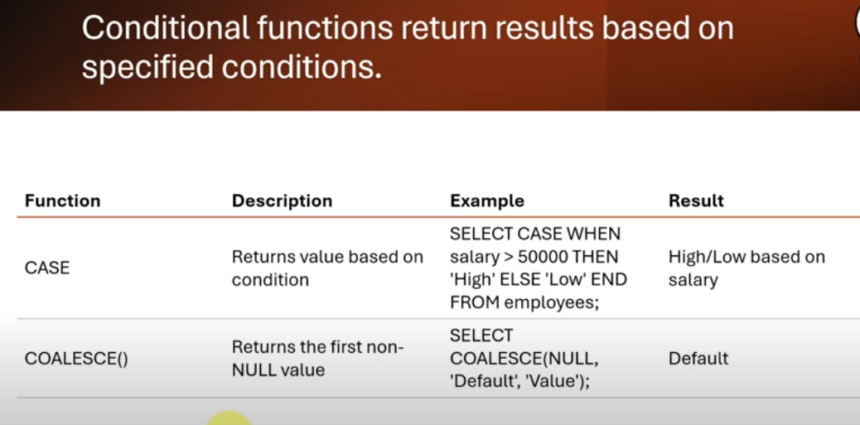

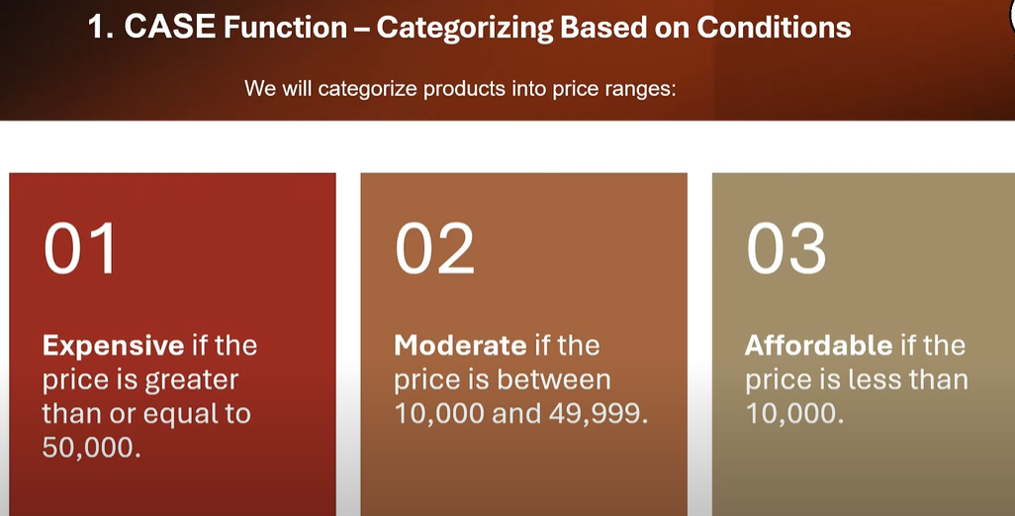

---conditional formatting-----

select * from products;

---1. case function - categorizing based on conditons-

--we will catgorize products into price ranges--

--expensive if the price is greater than or equal to 50k--

--moderate if the price is between 10k & 49,999---

--affordable if the price is less than 10k----

select product_name,price,

case

when price >=50000 then 'expensive'

when price >=10000 and price<=49999 then 'modearte'

else

'affordable'

end as pric_Category from products;

# **Assignment on Case Functions in SQL**

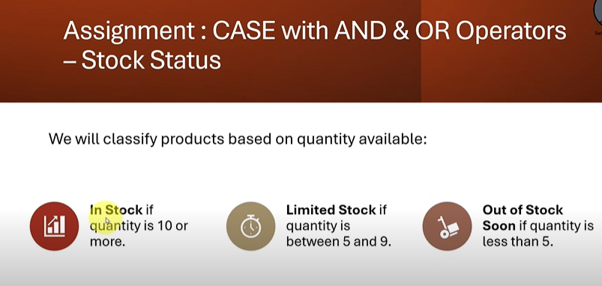

----Assignment 1 ----

select product_name,Quantity,price,

case

when Quantity >= 10 then 'in stock'

when Quantity >=5 and Quantity<=9 then 'limited stock'

else

'out of stock'

end

as pric_Category from products;

-----or----

select product_name,Quantity,price,

case

when Quantity >= 10 then 'in stock'

when Quantity between 6 and 9 then 'limited stock'

else

'out of stock'

end

as pric_Category from products;

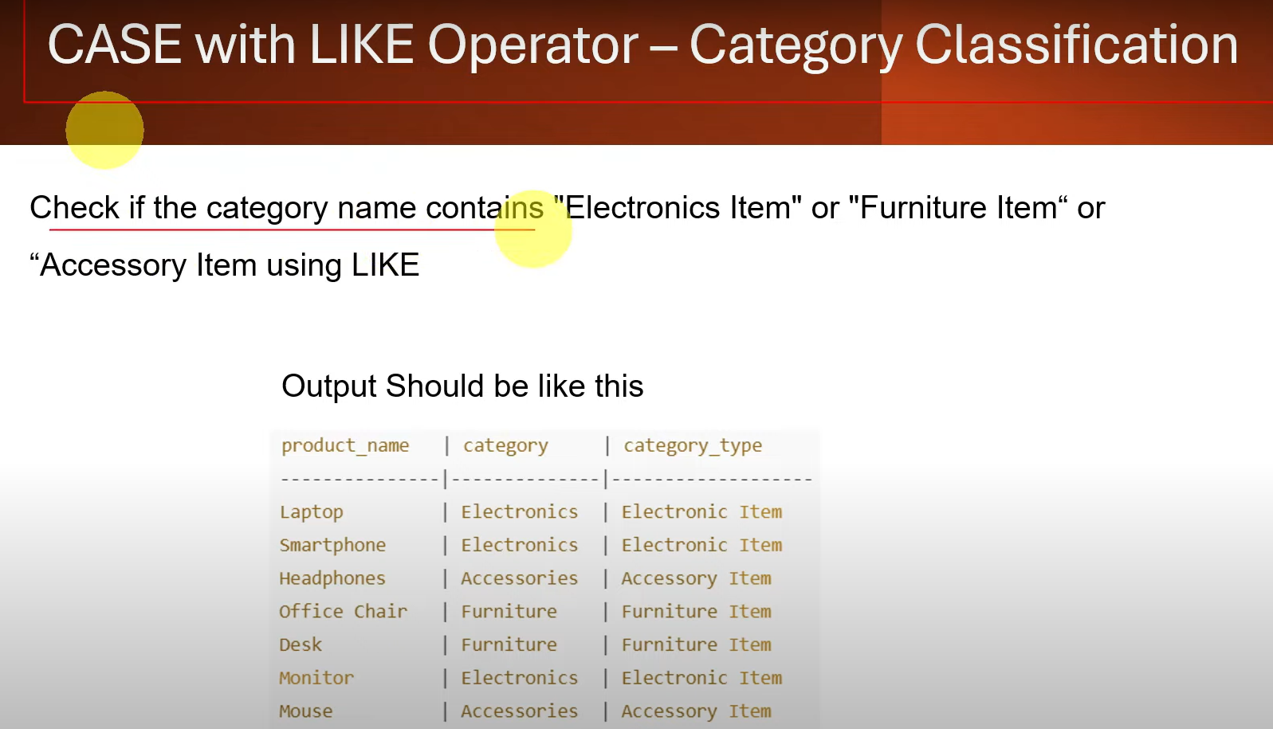

Assignment 2

select product_name,category,

case

when category like 'electronics%' then 'elctronic item'

when category like 'furniture%' then 'furnitureitem '

else

'Accessories item'

end

as Category_type from products;